zqdatacore-synapse019-dev-private-endpoint

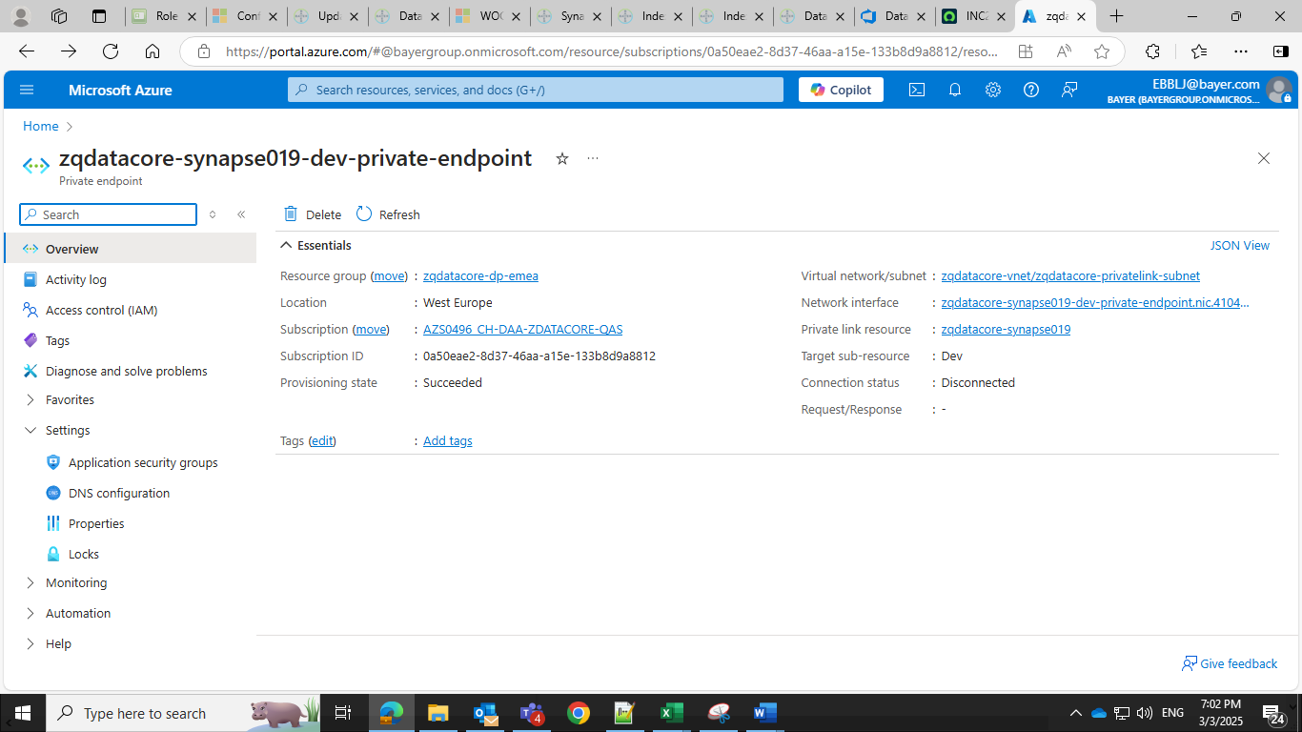**pe-stazdatacoreqa**

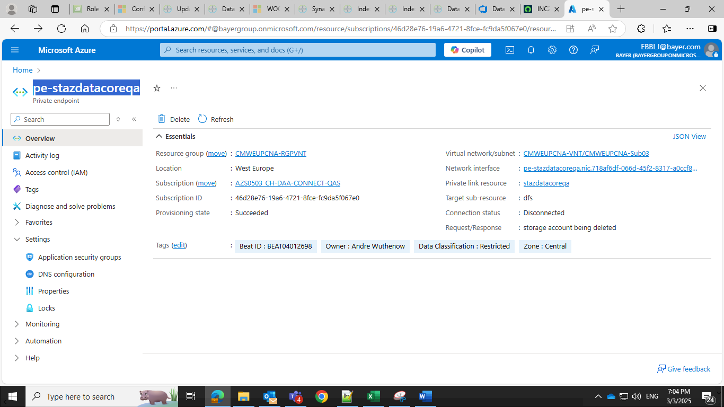oh22-sqltest-umi-private-endpoint

pe-zdatacoresdbxsta-blob

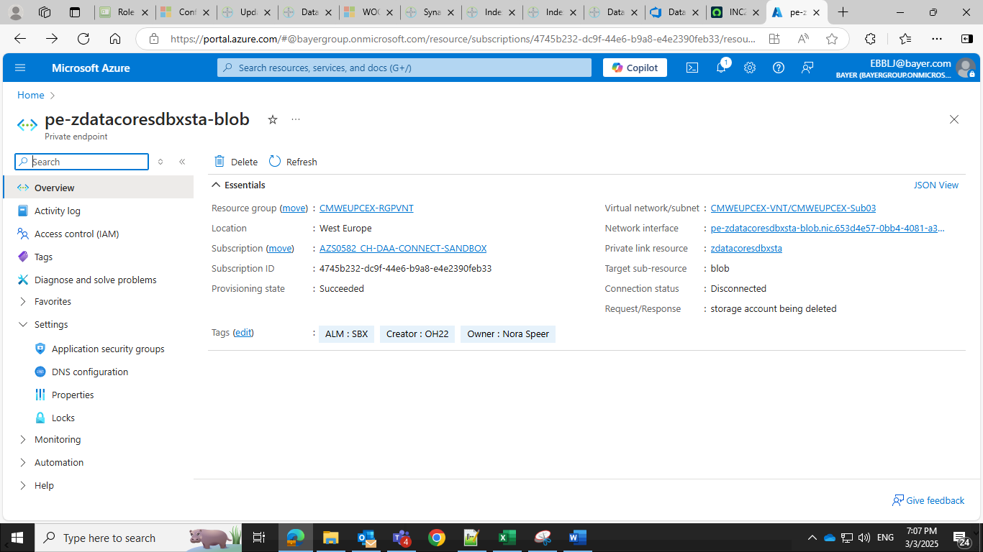pe-zdatacoresdbxsta-dfs

pe_keyvault_flowlogtest_sbx

zdmanage-blob-functionheddasa2-private-endpoint

zdmanage-app-heddaio-dotnet-webrunner-private-endpoint

dbx-test-oh22-1907-private-endpoint-dev

dbx-test-oh22-1907_auth-private-endpoint-dev

zdmanage-app-heddaio-dotnet-webrunner-private-endpoint

zdmanage-app-heddaio-spark-webrunner-private-endpoint

zdmanage-sql-heddaio-appdev1-pe

